In this assignment, I added three different interactions to the parellel coordinate project that I did earlier. Below I am listing the taken activities:

1_ As the first interaction, I added exploring interaction to the project. Here, we can change the position of the camera via keyboard input. Up and Down arrows change the vertical coordinate (i.e. y) of the camera and Left and Right arrows change the horizontal (i.e. x) coordinate of camera.

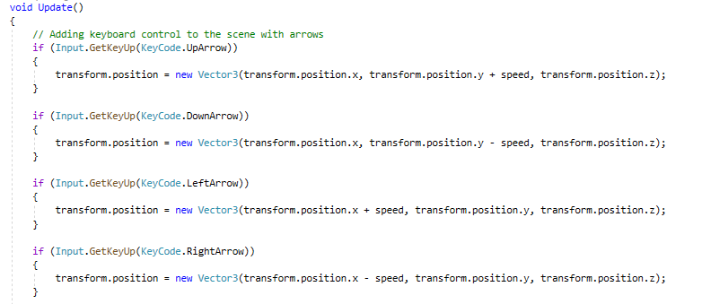

2_ In addition, mouse scroll adds zooming effect into the project. Via scrolling, the depth (i.e. z) coordinate of the camera changes.

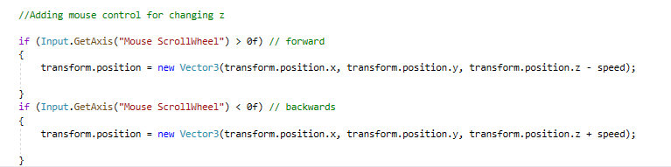

3_ The other added element to the project is selection. I added a collider component to each LineRenderer, and used RaycastHit and Ray element to see if each LineRenderer collides with the current position of mouse cursor after left-clicking. After clicking on the LineRenderer, its color is changed to yellow. If we left-click again on a selected LineRenderer, its color will be back to the original format.

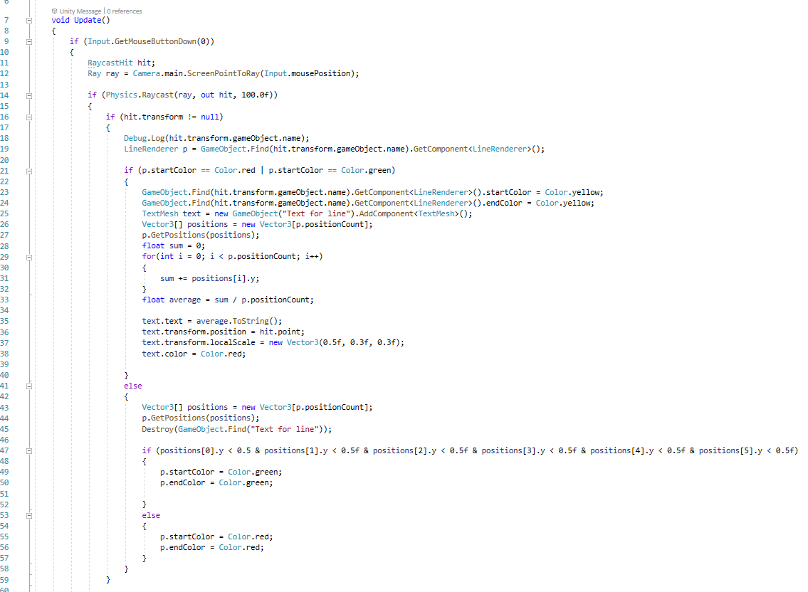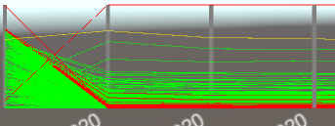

4_ As the final interaction, after left-clicking on each line, the average of normalized features (i.e. the value of each parallel axis that the selected LineRenderer hits) is shown next to the left-clicked point. After clicking on the selected line again, the text disappears.

